**ST Assignment No.3**

**Q1. Explain Formal Review in static white box testing.**

**Ans.**

1. *A formal review is the process under which static white-box testing is performed.*
2. *A formal review can range from a simple meeting between two programmers to a detailed, rigorous inspection of the code.*

* There are four essential elements to a formal review

1. *Identify Problems: - .The goal of the review is to find problems with the software—not just items that are wrong, but missing items as well. All criticism should be directed at the code, not the person who created it. Participants shouldn’t take any criticism personally. Leave your egos, emotions, and sensitive feelings at the door.*
2. *Follow Rules: - A fixed set of rules should be followed. They may set the amount of code to be reviewed (usually a couple hundred lines), how much time will be spent (a couple hours), what can be commented on, and so on. This is important so that the participants know what their roles are and what they should expect. It helps the review run more smoothly.*
3. *Prepare: - Each participant is expected to prepare for and contribute to the review. Depending on the type of review, participants may have different roles. They need to know what their duties and responsibilities are and be ready to actively fulfil them at the review. Most of the problems found through the review process are found during preparation, not at the actual review.*
4. *Write a Report: - The review group must produce a written report summarizing the results of the review and make that report available to the rest of the product development team. It’s imperative that others are told the results of the meeting—how many problems were found, where they were found, and so on*.

**Q2. Explain concept of Peer Reviews, Walkthroughs, Inspections.**

**Ans.**

1. ***Peer Reviews***
2. *The easiest way to get team members together and doing their first formal reviews of the software is through peer reviews, the least formal method.*
3. *Sometimes called buddy reviews, this method is really more of a discussion.*
4. *Peer reviews are often held with just the programmer who wrote the code and one or two other programmers or testers acting as reviewers.*
5. *Small group simply reviews the code together and looks for problems and oversights.*
6. *To assure that the review is highly effective all the participants need to make sure that the four key elements of a formal review are in place: Look for problems, follow rules, prepare for the review, and write a report.*
7. *As peer reviews are informal, these elements are often scaled back. Still, just getting together to discuss the code can find bugs.*
8. ***Walkthroughs***
9. *Walkthroughs are the next step up in formality from peer reviews.*
10. *In a walkthrough, the programmer who wrote the code formally presents (walks through) it to a small group of five or so other programmers and testers.*
11. *The reviewers should receive copies of the software in advance of the review so they can examine it and write comments and questions that they want to ask at the review.*
12. *Having at least one senior programmer as a reviewer is very important.*
13. ***Inspections***
14. *Inspections are the most formal type of reviews.*
15. *They are highly structured and require training for each participant.*
16. Inspections are different from peer reviews and walkthroughs in that the person who presents the code, the presenter or reader, isn’t the original programmer.
17. *These forces someone else to learn and understand the material being presented, potentially giving a different slant and interpretation at the inspection meeting.*
18. *The other participants are called inspectors.*
19. *Each is tasked with reviewing the code from a different perspective, such as a user, a tester, or a product support person.*
20. *This helps bring different views of the product under review and very often identifies different bugs.*
21. *One inspector is even tasked with reviewing the code backward—that is, from the end to the beginning—to make sure that the material is covered evenly and completely.*

**Q3. Explain data declaration errors & computational erros.**

**Ans.**

1. ***Data Declaration Errors***

Data declaration bugs are caused by improperly declaring or using variables or constants.

1. *Are all the variables assigned the correct length, type, and storage class? For example, should a variable be declared as a string instead of an array of characters?*
2. *If a variable is initialized at the same time as it’s declared, is it properly initialized and consistent with its type?*
3. *Are there any variables with similar names? This isn’t necessarily a bug, but it could be a sign that the names have been confused with those from somewhere else in the program.*
4. *Are any variables declared that are never referenced or are referenced only once?*
5. *Are all the variables explicitly declared within their specific module? If not, is it understood that the variable is shared with the next higher module?*

# Computation Errors

Computational or calculation errors are essentially bad math. The calculations don’t result in the expected result.

1. *Do any calculations that use variables have different data types, such as adding an integer to a floating-point number?*
2. *Do any calculations that use variables have the same data type but are different lengths—adding a byte to a word, for example?*
3. *Are the compiler’s conversion rules for variables of inconsistent type or length understood and taken into account in any calculations?*
4. *Is the target variable of an assignment smaller than the right-hand expression?*
5. *Is overflow or underflow in the middle of a numeric calculation possible?*
6. *Is it ever possible for a divisor/modulus to be zero?*
7. *For cases of integer arithmetic, does the code handle that some calculations, particularly division, will result in loss of precision?*
8. *Can a variable’s value go outside its meaningful range? For example, could the result of a probability be less than 0% or greater than 100%?*

**Q4. Differentiate between dynamic white box testing and debugging.**

**Ans.**

1. *It’s important not to confuse dynamic white-box testing with debugging.*
2. *The goal of dynamic white-box testing is to find bugs. The goal of debugging is to fix them.*
3. *They do overlap, however, in the area of isolating where and why the bug occurs. You’ll learn more about this later about, “Reporting What You Find,” but for now, think of the overlap this way.*
4. *As a software tester, you should narrow down the problem to the simplest test case that demonstrates the bug.*
5. *If its white-box testing, that could even include information about what lines of code look suspicious.*
6. *The programmer who does the debugging picks the process up from there, determines exactly what is causing the bug, and attempts to fix it.*

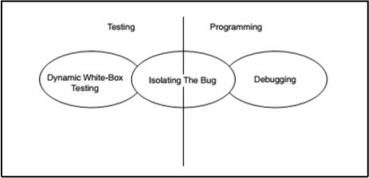

**Q5. Explain Unit and Integration Testing in SDFC/ V-Model illustrating with suitable block diagram.**

**Ans.**

* + *Unit and Integration Testing*

1. *As a large project or an application software is divided into small modules* or units to reduce the complexity and to minimize the failure rate of the software.
2. *Unit testing tests all the modules separately for the functionality and the the correctness of each module.*
3. *The integration testing is than implemented for the following reasons*
   * *To test that the output of one unit or module when given as an input to the second module does not affect the output and the correctness of the integrated module.*
   * *The change made to one module gives the effective and correct output of the integrated module and software as a product does not fail.*
   * *The parameters of one module match the parameters of the other module with respect to the permissible values, boundary conditions, correctness and utilization.*
   * *The figure shows the concept of unit testing and integration testing in V model.*
   * *There are two basic types of integration (i) top down integration (ii) bottom up integration.*

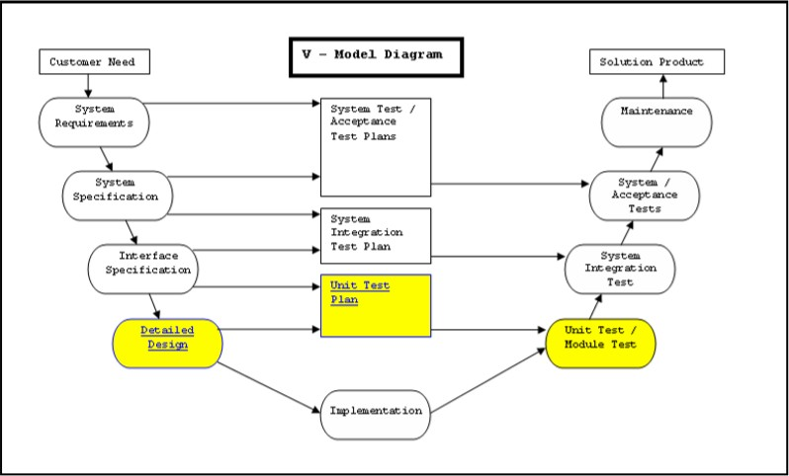

**Q6. Describe comparison errors and control flow errors.**

**Ans.**

# Comparison Errors

Comparison and decision errors are very susceptible to boundary condition problems.

1. *Are the comparisons correct? It may sound pretty simple, but there’s always confusion over whether a comparison should be less than or less than or equal to.*
2. *Are there comparisons between fractional or floating-point values? If so, will any precision problems affect their comparison? Is 1.00000001 close enough to 1.00000002 to be equal?*
3. *Does each Boolean expression state what it should state? Does the Boolean calculation work as expected? Is there any doubt about the order of evaluation?*
4. *Are the operands of a Boolean operator Boolean? For example, is an integer variable containing integer values being used in a Boolean calculation?*

# Control Flow Errors

Control flow errors are the result of loops and other control constructs in the language not behaving as expected.

1. *They are usually caused, directly or indirectly, by computational or comparison errors.*
2. *If the language contains statement groups such as begin...end and do...while, are the ends explicit and do they match their appropriate groups?*
3. *Will the program, module, subroutine, or loop eventually terminate? If it won’t, is that acceptable?*
4. *Is there a possibility of premature loop exit?*
5. *Is it possible that a loop never executes? Is it acceptable if it doesn’t?*
6. *If the program contains a multi way branch such as a switch...case statement, can the index variable ever exceed the number of branch possibilities?*

**Q7. Explain the following:**

1. **Error Forcing.**

**Ans.**

1. *The last type of data testing covered in this chapter is error forcing.*
2. *Testing the software in a debugger has the ability to watch variables and see what values they hold.*
3. *In the preceding compound interest calculation, if you couldn’t find a direct way to set the number of compounding (n) to zero, you could use your debugger to force it to zero.*
4. *The software would then have to handle it or not.*
5. **Code Coverage.**

**Ans.**

1. *Black-box testing, testing the data is only half the battle.*
2. *For comprehensive coverage you must also test the program’s states and the program’s flow among them.*
3. *You must attempt to enter and exit every module, execute every line of code, and follow every logic and decision path through the software.*
4. *Examining the software at this level of detail is called Code-coverage analysis is a dynamic white-box testing technique because it requires you to have full access to the code to view what parts of the software you pass through when you run your test cases.*
5. **Line Coverage.**

**Ans.**

1. *The most straightforward form of code coverage is called statement coverage or line coverage.*
2. *If you’re monitoring statement coverage while you test your software, your goal is to make sure that you execute every statement in the program at least once.*
3. *With line coverage the tester tests the code line by line giving the relevant output.*

For example

1. *#include<stdio.h>*
2. *void main() 3. {*
3. *int i , fact= 1, n;*
4. *printf(“enter the number “);*

6. scanf(“%d”, &n); 7. for(i =1 ;i <=n; i++)

1. *fact = fact * i;*
2. *printf (“the factorial of a number is ”%d”, fact);*

10. }

1. **Branch and Condition Coverage.**

**Ans.**

# Branch Coverage

1. *Attempting to cover all the paths in the software is called path testing.*
2. *The simplest form of path testing is called branch coverage testing.*
3. *To check all the possibilities of the boundary and the sub boundary conditions and it’s branching on those values.*
4. *Test coverage criteria requires enough test cases such that each condition in a decision takes on all possible outcomes at least once, and each point of entry to a program or subroutine is invoked at least once.*
5. *Every branch (decision) taken each way, true and false.*
6. *It helps in validating all the branches in the code making sure that no branch leads to abnormal behaviour of the application.*

# Condition Coverage

1. Just when you thought you had it all figured out, there’s yet another complication to path testing.

2. Condition coverage testing takes the extra conditions on the branch statements into account.